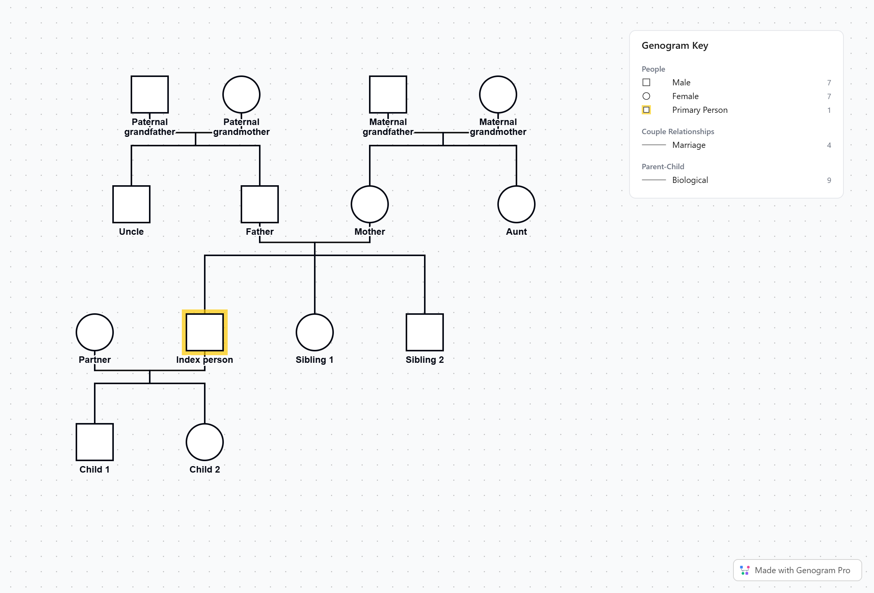
Genogram template from genogrampro.com/genogram-template. Replace the role labels with names, or open the editable version at genogrampro.com/free-genogram-maker.

