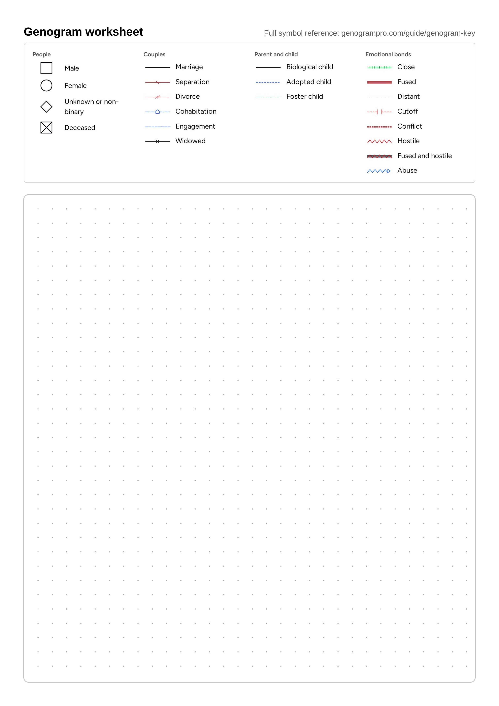
Genogram worksheet from genogrampro.com/genogram-template. Full symbol reference at genogrampro.com/guide/genogram-key.

